1. Design a clean and organized layout for the webpage using HTML.

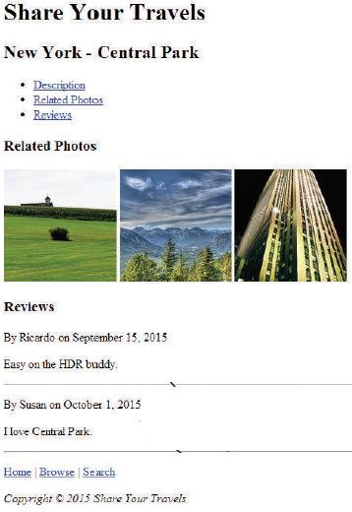

1. Develop a HTML program to illustrate an Employee registration form which accepts Employee’s Name (max 30 characters and only characters), Address (text area), Email (required field), Password, Phone Number, State, Gender (Use radio Button), Date of Birth, Languages known (check boxes – Kannada, English, Hindi, Spanish), Employee photo and any text document such as resume. Use Submit button and clear buttons.

3. Develop an HTML table to display the weekly class timetable, spanning Day 1 through Day 6 as below. When clicking on Skill Lab and Placement activity, corresponding information should display on the right (use float property). Use the suitable CSS Properties and selectors to apply styles to the text and margin & padding to create a balanced style. Implement a hover effect that slightly increases the text size.

|  |  |  |  |  |  |  |  |  |  |
| --- | --- | --- | --- | --- | --- | --- | --- | --- | --- |
| **DAY/TIME** | **8:30 – 9:30** | **9:30 – 10.30** | **10:30**  **–**  **11:00** | **11:00 – 12:00** | | **12:00 – 1:00** | **1:00**  **–**  **2:00** | **2:00 – 3:00** | **3:00 – 4:00** |
| **Day 1** | **21CSE63** | **21CSE62** | **SHORT BREAK** | **21CSE61** | | **Tutorial** | **LUNCH BREAK** | **MOOCs** | |
| **Day 2** | **21CSE65X (Open Elective)** | | **B1- 21CSEL69**  **B2- 21CSE63** | | | **21CIV67** | **Mentoring Session** |
| **Day 3** | **21CSE61** | **21CSE642/**  **21CSE644** | **21CSE662** | **21CSE62** | |  | |
| **Day 4** | **B2- 21CSEL69**  **B1- 21CSE63** | | **21CSE61** | **21CSE63** | | **Skill Lab** | |
| **Day 5** | **21CSE65X (Open Elective)** | | **21MPT68** | | | **Placement Activity** | |
| **Day 6** | **21CSE62** | **21CSE63** | **21CSE642/21CSE644** | | |

4. Write a JavaScript to design a simple calculator to perform the following operations: sum, difference, product and division. Display suitable error message if any non-numerical values are entered.

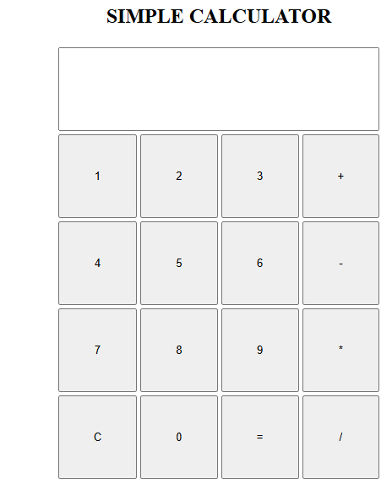

1. a. Develop a Javascript code that displays text “text-growing” with increasing font size in the interval of 100ms in red color, when the font size reaches 50pt it displays “text-shrinking” in blue color. then the font size decreases to 5pt.

b. Develop and demonstrate a html5 file that includes Javascript script that uses functions for the following problems

parameter: a string

output: the position in the string of the left-most vowel

parameter: a number

output: the number with its digits in the reverse order

6. Design a multicolumn layout using CSS positioning and z-index to achieve overlapping columns

a. Create an HTML structure for the multicolumn layout, including three columns.

b. Use CSS positioning properties to arrange the columns side by side.

c. Utilize z-index and CSS positioning to achieve an overlapping effect for the columns.

d. Ensure that the columns partially overlap each other while maintaining readability.

e. Populate each column with different content sections, including headings, paragraphs, and images.

f. Apply background colors or patterns to the columns to enhance the visual separation between them.

7. Design a portfolio webpage using **Bootstrap** to showcase your skills and projects

a. Design a header section with your name or a logo.

b. Use Bootstrap's navbar component to create a simple navigation bar.

c. Add a brief introduction about yourself or your work.

d. Utilize Bootstrap's typography classes for consistent styling.

e. Create a section to list your skills or areas of expertise.

f. Use Bootstrap's card component to present each skill.

g. Display a grid of project cards, each with a project name, image, and brief description.

8. Using React JS, create a web page that reads name from the form and displays it.

9. Develop a simple student registration application, with fields for USN,name, department, and subject code using React.

10.Develop a Backend database to store information in Mongo Db database using Node JS for the Program